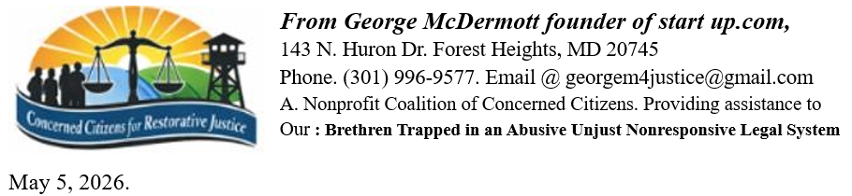
Congressman Jim Jordan
US. Chairman House Judiciary Committee.
R. H/O. Building Room 2056
Washington, District of Columbia 20005 Being hand-delivered to all 44 committee members

Dear Esteemed committee member: Of our United States House Committee Judiciary Committee as a concerned citizen and victims’ rights advocate, as well as a victim myself, I am now contacting this committee as a whole and each of its members personally by hand delivering to the 44 committee members offices on Capitol Hill, a formal request for a meeting to present evidence of our agencies disrespect of their core mission statement. Plus the blatant abuse of the legal process and secrecy that has overtaken our nation’s judicial system, the DOJ, the FBI, Homeland Security/Ice. As a Sub Corporation of the parent corporation of the United States Corporate Government and its CEO Donald John J. Trump; of which each member of this committee as MEMBERS of the U.S. Congress acting as per 5 USC § 2902. et seq.
Each member of this committee acting as bonded agents and trust officers of the corporate entity Title 28 USC 3002 Section 15A states that the United States is a Federal Corporation and not a Government, including the Judiciary Procedural Section. operating as the U.S.A. Inc. Duns # 052714196. Our control and 28 USC §§ 1603 recorded published statutes of this body.
Committee Members. The Corporation Continually puts out propaganda stating if you see something say something and to report waste fraud and abuse in agencies which something that I George McDermott has done continuously since 1994. Only to be rewarded by the courts gifted away my partners and family’s business assets our multimillion dollar investments. Through the use of fraudulent use of unsigned orders and being defrauded and deceived by court agents and assigns for 30 years plus. This culture of corruption has exploded, from a $2.5 trillion deficit in1998 in which is now approaching $ 40 trillion dollars. According to latest published statistics...?
I am delivering this message on behalf of my fellow citizens who no longer have access to the court systems of these United States as our Mafia controlled legal system fails 97% of our citizens, It is shameful that court insiders and corporate lawyers openly promote fraud on the courts by their corporate clients and political insiders. Playing our system of injustice for most like a finely tuned fiddle. What has happened to equal justice and equal protection under the law…? F/N-1.
F/N-1. Federal Evidence: Rule 902(13) & (14) These rules allow for the self-authentication of certified records generated by an electronic process or system. If an order or decree lacks a tracking number, noncompliant documents that cannot be authenticated are also not "self-authenticating" and should be challenged as a hearsay/forgery under federal standards. Question why are our state and federal courts and agencies allowed to use of unsigned document and orders judgments.

